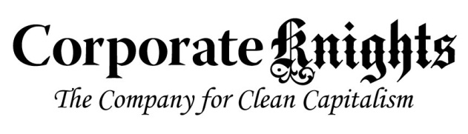

Media Release
Stimulus blueprint provides framework to “build back better”
Toronto, April 28, 2020 – Expert panels are presenting and testing sector-specific plans to “build back better” in the wake of the current economic shutdown, in a series of live online public roundtables running over the next several weeks. This “Build Back Better” strategy focuses on strategic investments that will deliver strong and quick-acting stimulus, while also accelerating the modernization and decarbonization of the Canadian economy in line with global growth trends.
Tomorrow’s discussion will be introduced by Infrastructure and Communities Minister Catherine McKenna, and focus on stimulus opportunities in the green power and transmission sector. Panelists will include chief executives of national clean-electricity industry associations, and expert commentators from Indigenous, capital markets and other stakeholder groups. (Full list here.)
Convened by Corporate Knights, each roundtable includes an overview of a sector-specific analysis of specific stimulus opportunities and their impacts and benefits, prepared by Torrie Smith Associates. Commentary is then invited from all panelists, and the discussions will inform refined proposals and recommendations that will be taken forward to government.
Last week’s inaugural webinar, introduced by Environment Minister Jonathan Wilkinson, focused on opportunities relating to building retrofits, and quantified benefits associated with a $26 billion stimulus investment in deep residential, industrial and commercial building retrofits. The “green renovation wave” this could generate is projected to create 220,000 jobs, $30 billion in electricity and fuel savings, and 87 million tonnes of reduced GHG pollution.
All webinars take place on Wednesdays at 11:00 a.m. E.T. The upcoming topics are:
- April 29 – Topping up our Green Power Sources, Storage and Connections
- May 6 – Electrifying our Cars, Trucks and Buses
- May 13 – Greening Heavy Industry
- May 20 – Building Back Better with Forests and Land
- May 27 – Fueling Innovation in the Energy Sector
- June 3 – Building Back Better: Wrap up and Next Steps
Full details will be available here as each panel is finalized.
About Corporate Knights: Corporate Knights Inc. includes the sustainable business magazine Corporate Knights and a research division that produces rankings and financial product ratings based on corporate sustainability performance.
-Ends-
Contact information:
Toby Heaps, CEO, Corporate Knights
Phone: +1 (416) 274 1432
Email: toby@corporateknights.com

